PROJECT REPORT
Supermarket Sales and Billing System

Submitted by:
NOWEMBABAZI SHINAH
Reg No: 2025/BCS/203/PS
Date: 7th May, 2026
Area of Interest: Sales and Billing System

1. Executive Summary
This project presents the design and implementation of a database application for a supermarket's sales and billing system. The core objective of this system is to replace error-prone manual billing processes, improve inventory tracking, and provide accurate, automated sales reporting.
After evaluating several database architectures, a Relational Database Management System (RDBMS) using MySQL was selected because of its strong data organisational capabilities, ACID compliance, and support for concurrent users.
The system addresses critical problems such as inefficient checkout, revenue leakage, and poor inventory visibility. Through detailed logical and physical design, followed by system implementation with complex queries and user interfaces, the project successfully creates a streamlined platform supporting key user groups including cashiers, managers, inventory staff, and accountants.

Business Case

Problems Being Solved
The primary catalyst for this project was the need to resolve significant operational challenges present in a manual system. Key issues include:
- Manual Billing Errors: High frequency of calculation mistakes leading to incorrect totals.
- Inefficient Check-out Process: Slow processing and lengthy customer queues.
- Poor Inventory Visibility: Lack of real-time stock levels, leading to stockouts or overstocking.
- Revenue Leakage: Errors in calculation and untracked transactions.
- Time-Consuming Reporting: Compiling sales data manually is slow and delays critical business insights.

System Assumptions and Requirements
To resolve these issues, the new system must adhere to specific performance and functional criteria such as;
- Performance: The system must process transactions quickly and support multiple simultaneous users.
- Database Efficiency: Product data must be stored and retrieved efficiently.
- Reporting: Automated generation of comprehensive reports.
- Security: Ensure data security and prevent unauthorised access.
- Usability: The system must be simple and user-friendly for staff with varied computer skills.
Limitations
The system's operation depends entirely on electricity and network availability. Human error during data entry cannot be fully eliminated.

User Groups and Responsibilities
User Group | Responsibilities
Cashiers | Process daily sales and print customer receipts at the point of sale.
Managers | Oversee operations, generate detailed reports, and manage user accounts.
Inventory Staff | Monitor stock levels and manage the product catalogue (products, prices, barcodes).
Accountants | Reconcile payments, track revenue, and manage accounts receivable.
Customers | (Passive group) Receive clear receipts of their transactions.

Application Domain and Core Tasks
Operating within the retail/supermarket domain, the system automates several critical processes:
- Point of Sale (POS): Recording customer purchases, applying discounts, calculating taxes, and generating receipts.
- Inventory Management: Automatically updating stock levels upon every sale and generating low-stock alerts.
- Customer Management: Storing customer information, purchase history, and managing loyalty programmes.

Cost-Benefit Analysis
Tangible Benefits
- Accurate Billing: Reduces revenue leakage from manual calculation mistakes.
- Improved Inventory Tracking: Prevents costly stock shortages through automated tracking.
- Increased Efficiency: Speeds up checkout, allowing more customers to be served in less time.
- Data-Driven Decisions: Increased sales tracking leads to better business decision-making.
- Faster Reporting: Eliminates hours previously spent manually compiling data.
Intangible Benefits
- Enhanced Customer Satisfaction: Achieved via quick and accurate service.
- Professional Business Image: Modern system improves brand perception.
- Improved Decision Making: Management has faster access to critical data.
- Data Security: Secure storage of transaction data reducing risks.
Tangible Costs
- Hardware: Acquisition of computers, barcode scanners, and receipt printers.
- Software Development: Direct costs associated with designing and building the system.
- Staff Training: Expenses related to training users on the new software.
- Maintenance: On-going database setup and server maintenance.
Intangible Costs
- Learning Curve: Time required for staff to master the system.
- Resistance to Change: Human employee factors and potential disruption during implementation.

Risk Assessment and Mitigation
Risk Type | Specific Risk | Impact | Proposed Mitigation
Technical | System failure or crashes | Business unable to process sales. | Implement backup internet connection and UPS.
Technical | Data loss | Permanent loss of business records. | Automated daily backups and disaster recovery plan.
Technical | Security threats | Unauthorised access and data breaches. | Strict authentication, access control, and data encryption.
Organisational | Resistance from staff | Failure to adopt the new system. | Involve staff early; provide proper training sessions.
Organisational | Poor management support | Project stall or underutilisation. | Regular project updates and executive buy-in sessions.
Operational | Power Outage | Entire system becomes unusable. | Backup power supply (UPS) for critical hardware.
Operational | Network Issues | Prevents communication, affects updates. | Regular connectivity checks; offline processing where possible.

Database System and Platform

Platform Evaluation
A crucial component of this project was selecting the correct database management system. Several architectures were evaluated and these include;
- Relational Database Management System (RDBMS): e.g., MySQL, PostgreSQL, MS SQL Server, Oracle.
- NoSQL Database.
- Cloud-Based Database System: e.g., Google Cloud SQL, Amazon RDS, MS Azure SQL.
- Embedded Database: e.g., SQLite.
- Distributed Database.

System of Choice and Rationale
The primary database system selected for this supermarket project is MySQL, a leading open-source RDBMS. The choice was finalised based on the following justifications:
- Structured Data Organisation: Supermarket operations involve highly organised, relational data. RDBMS stores data in tables, facilitating clear organisation and preventing data duplication.
- Relationship Support: Directly supports critical data relationships by enforcing constraints using foreign and primary keys.
- ACID Compliance: MySQL supports Atomicity, Consistency, Isolation, and Durability — essential for financial sales transactions.
- Scalability: Capable of handling large datasets and supporting multiple simultaneous users.
- Ease of Use & Tooling: Well-documented and easy to learn, with extensive support from development tools.
- Security and Integrity: Provides robust security features including authentication and precise access control.
- Querying Power: Offers powerful querying and reporting capabilities for inventory analysis and sales reports.

Design: Logical and Physical Design

Logical Design (Entity-Relationship Diagram)
The logical design describes the overall structure of the database at an abstract level. Several key entities and relationships were identified for the supermarket's sales and billing workflow.
Entities and Key Attributes
- Product: Stores information about every item for sale.
- Attributes: product_id (PK), product_name, price, stock_quantity, barcode, category_id (FK).
- Category: Groups products for reporting.
- Attributes: category_id (PK), category_name.
- Customer: Stores details for customer tracking and loyalty programmes.
- Attributes: customer_id (PK), customer_name, phone.
- User: Manages system access.
- Attributes: user_id (PK), name, password , role, username.
- Sales: Records the master data of each completed sale.
- Attributes: sales_id (PK), sale_date, customer_id (FK), user_id (FK), total_amount.
- Sale_Item (Line Items): Tracks each item within a single transaction.
- Attributes: sale_item_id (PK), sales_id (FK), product_id (FK), quantity, price.
- Payment:
- Attribute: payment_id(PK), sale_id(FK), amount_paid, payment_date, payment_method.
Relationships and Cardinalities
Relationship | Cardinality | Notes
Product ↔ Category | Many-to-One | A product belongs to one category; a category holds many products.
User ↔ Sales | One-to-Many | One cashier can process many sales transactions.
Customer ↔ Sales | One-to-Many | Customer_id can be NULL to allow guest/non-loyalty sales.
Sales ↔ sale_item | One-to-Many | One transaction can contain multiple line items (products).

Physical Design (Table Schemas)
The physical design translates the logical model into actual database objects for MySQL. Each table is defined with precise column names, data types, and constraints.
Table: categories
Column Name | Data Type | Constraints | Description
category_id | INT | PRIMARY KEY, AUTO_INCREMENT | Unique identifier for the category.
Category_name | VARCHAR(100) | NOT NULL, UNIQUE | The name of the category (e.g., Dairy, Bakery).

Table: products
Column Name | Data Type | Constraints | Description
product_id | INT | PRIMARY KEY, AUTO_INCREMENT | Unique identifier for the product.
product_name | VARCHAR(100) | NOT NULL | Name of the product.
barcode | VARCHAR(100) | NOT NULL, UNIQUE | Barcode for scanning at POS.
price | DECIMAL(10,2) | NOT NULL | Selling price per unit.
stock_quantity | INT | NOT NULL | Current inventory count.
category_id | INT | FOREIGN KEY, NOT NULL | References categories(category_id).

Table: customers
Column Name | Data Type | Constraints | Description
customer_id | INT | PRIMARY KEY, AUTO_INCREMENT | Unique identifier for the customer.
customer_name | VARCHAR(100) | NOT NULL | Customer's full name.
phone | VARCHAR(20) | YES | Customer's contact phone number.

Table: users
Column Name | Data Type | Constraints | Description
user_id | INT | PRIMARY KEY, AUTO_INCREMENT | Unique identifier for the system user.
name | VARCHAR(100) | YES | Full name of the system user.
username | VARCHAR(50) | YES | Login username for the system.
password | VARCHAR(100) | YES | Hashed password for secure authentication.
role | VARCHAR(50) | YES | Defines user's access level.

Table: sales
Column Name | Data Type | Constraints | Description
sales_id | INT | PRIMARY KEY, AUTO_INCREMENT | Unique identifier for each sale.
sale_date | DATETIME | NOT NULL, DEFAULT NOW() | Timestamp of the transaction.
customer_id | INT | FOREIGN KEY, NULL | References customers(CustomerID). NULL for guests.
user_id | INT | FOREIGN KEY, NOT NULL | References users(UserID) — the processing cashier.
total_amount | DECIMAL(10,2) | NOT NULL | Final total amount charged to the customer.

Table: sale_items
Column Name | Data Type | Constraints | Description
sale_item_id | INT | PRIMARY KEY, AUTO_INCREMENT | Unique identifier for each line item.
sale_id | INT | FOREIGN KEY, NOT NULL | References sales(sales_id).
product_id | INT | FOREIGN KEY, NOT NULL | References product(product_id).
quantity | INT | NOT NULL | Number of units sold in this line item.
price | DECIMAL(10,2) | NOT NULL | Price of the product at time of sale.

Table: payment
Column Name | Data Type | Constraints | Description
payment_id | INT | PRIMARY KEY, AUTO_INCREMENT | Unique identifier for each payment.
sale_id | INT | FOREIGN KEY, YES | References sales(sales_id).
amount_paid | DECIMAL(10,2) | YES | Total amount paid for the sale.
payment_date | DATETIME | YES | Timestamp of the payment.
payment_method | VARCHAR(50) | YES | Method used for payment (e.g., Cash, Card).

5. Implementation: Screenshots and Queries
This section details the actual development of the supermarket sales and billing system, including user interface design, critical SQL queries, and table descriptions.
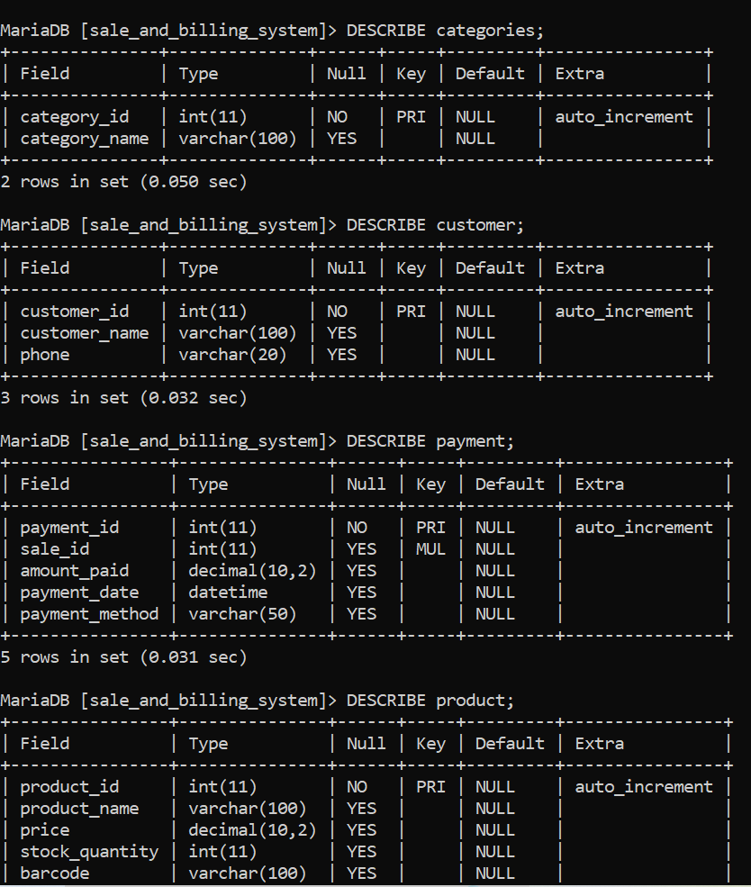
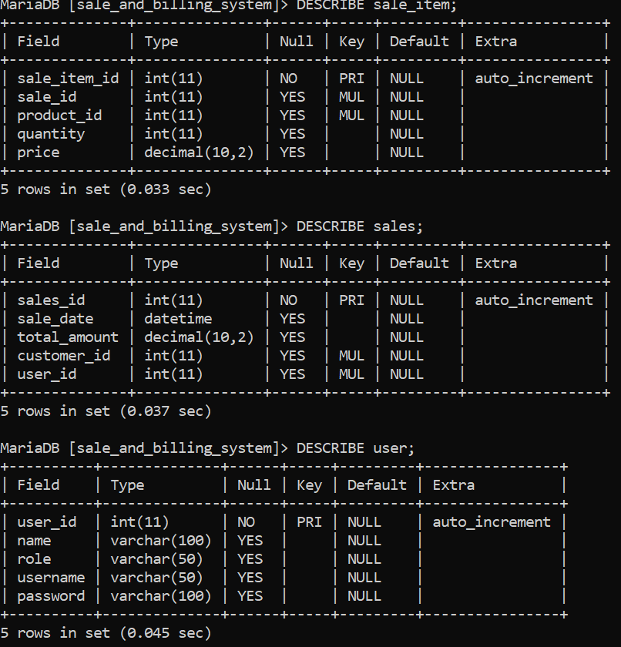

System Table Descriptions
The following descriptions reflect the actual tables created and deployed in MySQL. Run DESCRIBE table_name; in MySQL Workbench to confirm the structure matches the physical design above.
Table Name | Purpose | Key Columns
categories | Organises products into groups for reporting. | category_id (PK), category_name
products | Stores all product/inventory data. | product_id (PK), barcode, price, stock_quantity, category_id (FK)
customers | Holds customer data for loyalty tracking. | customer_id (PK), customer_name, phone
users | Controls system access and roles. | user_id (PK), name, role, username, password
sales | Master record of each completed sale. | sales_id (PK), sale_date, total_amount, customer_id (FK), user_id (FK)
sale_items | Line-item detail for each sale. | sale_item_id (PK), sale_id (FK), product_id (FK), quantity, price
payment | Records payment details for each sale. | payment_id (PK), sale_id (FK), amount_paid, payment_date, payment_method

Screenshots of the Implemented System

